PARAG SONI – R00208553
Student Examination Declaration
I declare that the work submitted is my own.
I declare that I have not obtained unfair assistance via use of the internet or a third party in the completion of this examination.
I acknowledge that the Academic Department reserves the right to request me to present for oral examination as part of the assessment regime for this module.
I confirm that I have read and understood the policy and procedures concerning academic honesty, plagiarism and infringements.
I understand that where breaches of this declaration are detected, these will be reviewed under CIT’s policy and procedures concerning academic honesty, plagiarism and infringements, as well as any other Institute regulations and policies which may apply to the case. I also understand that any breach of academic honesty is a serious issue and may incur penalties

DATA SET - Pegs
INTRODUCTION
The dataset provided gives the data of 80 applicants aged between 18-30 years inclusively, with or without previous experience. Applicants underwent an agility test as part of recruitment procedure for assembly line worker. The test examines applicants based on the number of strangely shaped pegs one can fit into matching holes. This has 4 variables: Gender, Age, PreviousExp, NoPegs .
First step to classifying the data between Cate.
- Age, NoPegs, are Nominal data.
- Gender, PrevExp – Categorical Data
Initially the data has been simplified by adding new columns for Gender, PrevExp, and categorizing age as it’s a continuous data. Proceeding further, interrogating it using frequencies, histograms, Stem-and-Leaf Plots, Ogive and pie charts. The above mentioned analysis will help us have an understanding of data, potential findings as well as relationship between various data variables.

Brief Analysis

The analysis of the Gender, Age and Previous Experience data provide us gate to dig dataset.
There are total 80 applicants out of which 51.25% that’s 41 are Female and 48.25% which is 39 are male which clearly indicate there are 2 more females than Male.

Total of 80 applicants 42 has previous experience that’s 52.5% and 38 have no experience.
No Yes
38 42

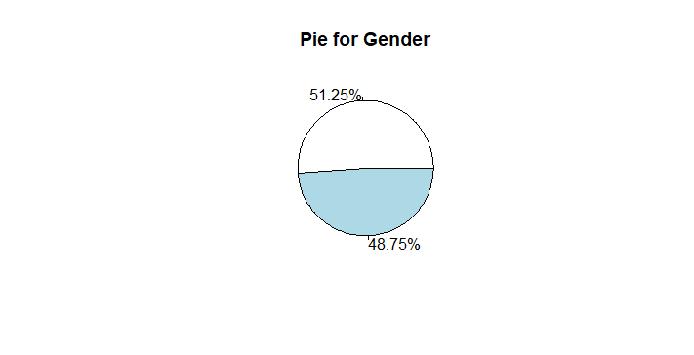
When comparing Gender and there Previous experience, its indicated that males with experience performed well as compared to females and vice versa.
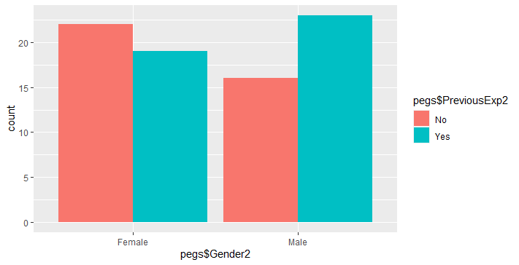

Questions to Analyse/ Relations to identify
- Distribution of Number of Pegs fitted
Solution :- The minimum number of pegs fitted is 16 by a male , and the maximum number is 29 that too by a male. However the mode that is the most number of applicant with the same number of pegs fitted is 21, and the distribution is 11 females and 6 males.
Min. 1st Qu. Median Mean 3rd Qu. Max.
16.00 19.00 21.00 20.56 22.00 29.00
Mode – 21
Female Male
16 0 1
17 4 4
18 3 4
19 6 3
20 5 9
21 11 6
22 7 4
23 3 3
24 2 2
26 0 1
28 0 1
29 0 1
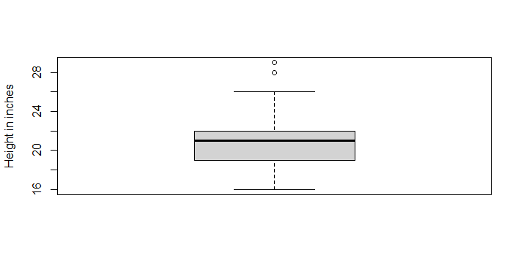
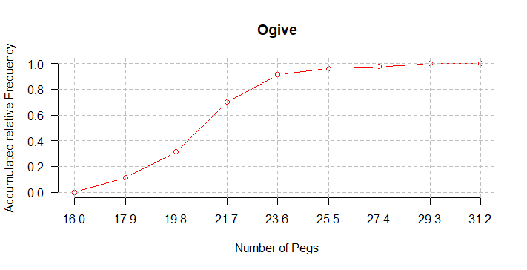

Question 2 – Distribution of number of pegs wuth respect to gender
Female Male
Between 15 & 21 18 21
Between 20 & 26 23 15
Between 25 & 31 0 3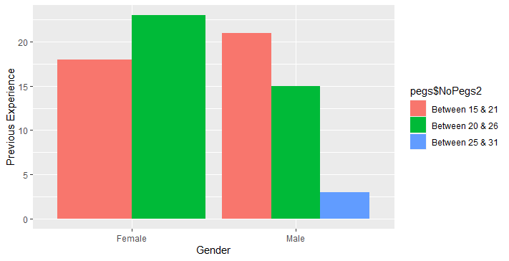
The above Graph clear states the relation between gender and the number of pegs they fitted, since number of pegs is comntinous its divided in range, 15-21, 20-26, 25-31 exclusively.
Number of females, who fitted between 15-21- are 18,
Number of females, who fitted between 20-26- are 23,
Number of females, who fitted between 25-31- are none,
Number of males, who fitted between 15-21- are 21,
Number of males, who fitted between 20-26- are 15,
Number of males, who fitted between 25-31- are 3,
This states that none of the female fitted more than 25, however there were 3 males to fit. Ver most number of pegs fitted between 20-26, which can be consider as close to highest by female are higher that that of male which is 23 while male is 15, and the lowest range that’s 15-21 pegs, males were 21 in the range which is 3 more than females.
Conclusion can be derived that females performed well in the agility test as

Question 3 No of pegs vs Previous experience
No Yes
Between 15 & 21 19 20
Between 20 & 26 17 21
Between 25 & 31 2 1

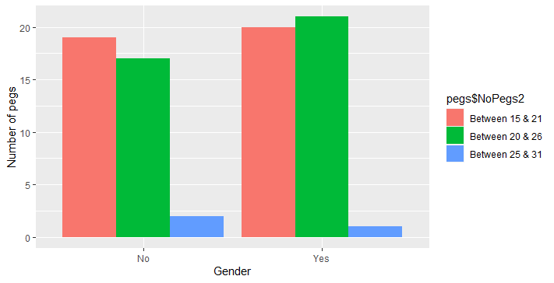
From the above graph, we can derive that, the number of pegs fitted by applicant with experience is more which is 42 and that without experience is 38. However contradicting part is that max no of pegs fitted by non- experience holder is more than, experience holders.

Conclusions
After reviewing these last graphics, I would suggest that
- it doesnt really matter whether one have experience or not:
- Females performed better than males
- Females were more in numbers in respect to age while males more males were younger.

It would have been better if we had more data on peoples.

